Install Prometheus and Grafana on a Linux EC2 machine, connect Prometheus to Grafana, and create a dashboard to view metrics.

Prometheus and Grafana are two powerful tools that help to monitor and visualize how your applications and systems are working.

Prometheus is a monitoring tool that collects real-time metrics data of your applications and infrastructure, like how much CPU or memory is being used, how many requests your app is getting, and more. It keeps this information updated all the time. To visualize this data, we use Grafana.

Grafana is an ultimate dashboard tool that takes this data and shows it in the form of charts and dashboards. This makes it easy to see what is happening in your system.

Terminologies in Prometheus and Grafana

Metrics: Metrics represent specific types of data that you want to be monitor. It is usually a numerical value that reflects a portion of system performance or resource consumption. For example: CPU usage, memory usage, and number of requests per second.

Time series data: In Prometheus, metrics can be stored as time series in data, which means that each data point is associated with a timestamp. This allows tracking metric changes over time. Example: CPU utilization of the server is recorded every second.

Prom-QL: PromQL contains a powerful query language for querying and retrieving time-series data from Prometheus. Example: rate(http requests total) retrieves the number of HTTP requests per second in the last 5 minutes.

Exporter: An exporter is a feature that collects metrics from a specific system and displays them in a format that can be flushed by Prometheus. Example: Node Exporter for hardware and OS metrics, MySQL Exporter for MySQL database metrics.

Alerts: A mechanism that allows Prometheus to generate alerts based on predefined conditions. Alerts can be routed to reporting systems. Example: If CPU utilization exceeds 90% for more than 5 minutes, an alert is generated.

Target: The value is every system from which Prometheus pulls metrics. The goals are defined in the Prometheus framework.

Step 1: Install a Grafana from Grafana Cloud

1. Sign up for a Grafana here.

2. In a Remote write your metrics for the Grafana.com Prometheus instance

3. Add the following code in your prometheus.yml file to begin sending metrics to be your hosted Grafana instance:

remote_write:
- url: <https://your-remote-write-endpoint>
basic_auth:
username: <your user name>
password: <Your Grafana.com API Key>

Step 2: Install a Grafana using the Docker

1. Download the Grafana using a docker-compose.

version: '3'
services:
...
grafana:
image: grafana/grafana:8.1.5
ports:
- 3000:3000

2. Open the Grafana by a going to http://localhost:3000 in a your web browser. For Log in with the default username is (admin) and password is (admin). Add for a data source is:

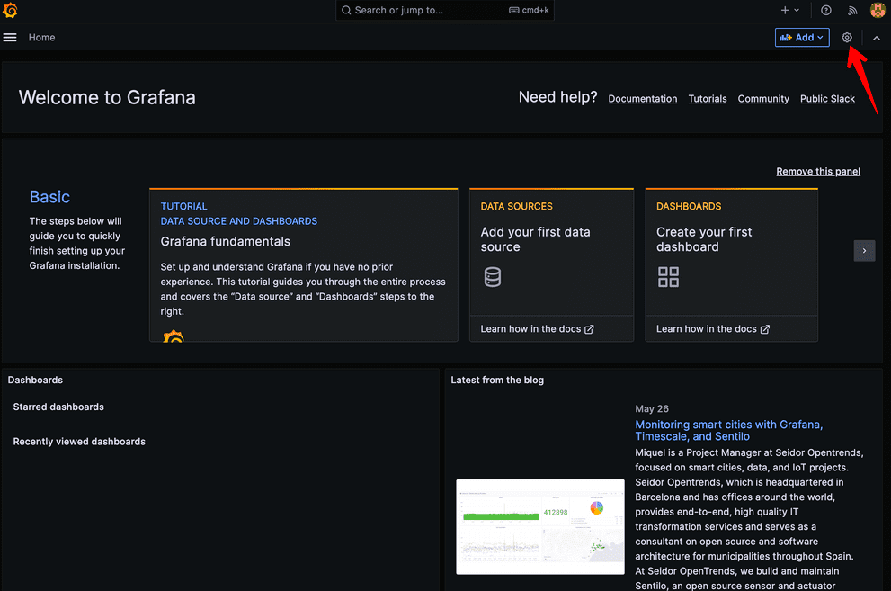

Step 3: Add Prometheus as a Data Source in Grafana

1. Click the Grafana icon in top left corner, click "Configuration" and then click "Data Sources".

2. Click on "Add data source", select Prometheus as type. Enter the URL of Prometheus server.

3. Enter your Prometheus URL (e.g., http://prometheus:9090 if using Docker).

4. Click "Save & Test".

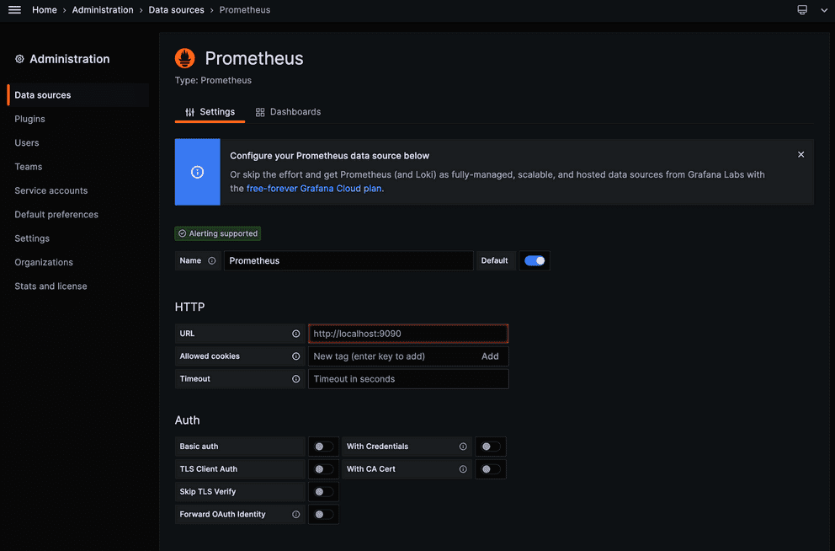

Step 4: Create a dashboard

1. Click on Grafana icon in top left corner and click "Create" and then a click on "Dashboard".

2. Click a "Add new panel".

3. Enter Prometheus expression in a query field, such as a

100 - (avg by(instance) (irate(node_cpu_seconds_total{work="node",mode="idle"}[5m])) * 100)

This query shows CPU utilization.

4. Modify to a graph layout as a desired.

5. Click to "Apply".

Step 5: Prometheus Metrics in a Grafana

1. In your Grafana instance, go to Explore view and build queries to experiment with the metrics you want to monitor.

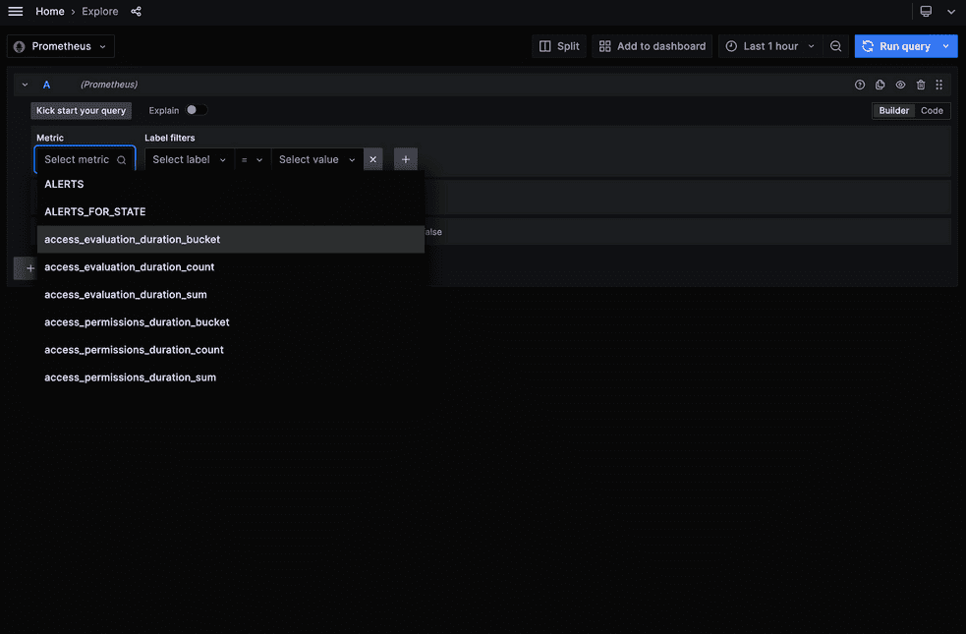

2. Create a dashboards to a display system metrics monitored by a Prometheus.

3. In Grafana dashboards can also be a represented as JSON images. To share a dashboard, you can click "Share dashboard" and then "Export for sharing externally" to get JSON model. To import the dashboard you can add JSON model to "Import" field.

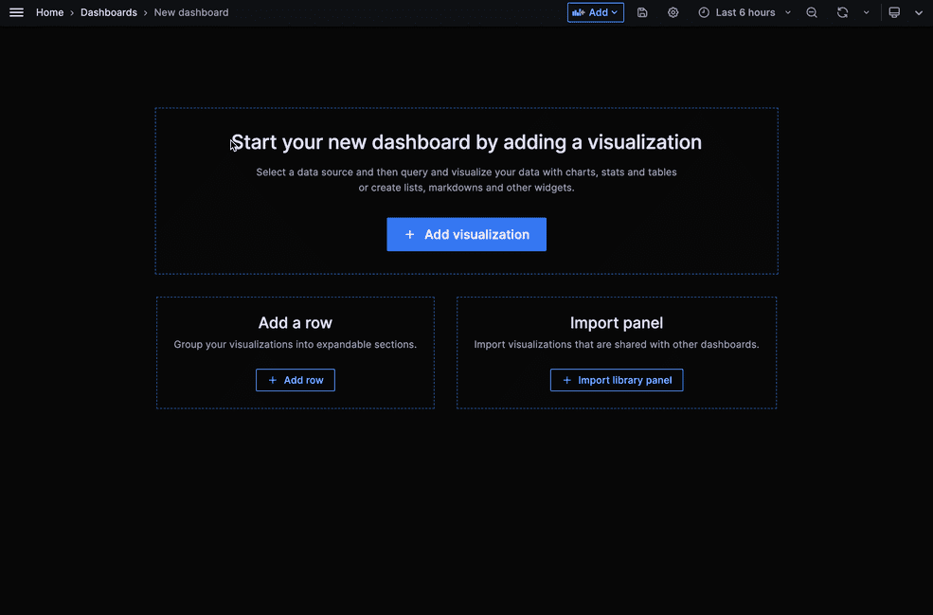

Monitoring Kubernetes Clusters with Prometheus and Grafana

In modern era of containers, Kubernetes has emerged as a leading band. like any robust system, effective assessment is critical to ensuring it works, reliably and is scalable. Prometheus and Grafana, two powerful tools, combine to provide robust solution for managing a Kubernetes clusters. This article will guide you through setting up and using Prometheus and Grafana to manage your Kubernetes clusters.

Step-By-Step to Monitoring Kubernetes Clusters with Prometheus and Grafana

Step 1: Create a Namespace and Add Helm Charts Repo

In a first step is to create a namespace within the Kubernetes cluster. It will be establish a separate vicinity on your Kubernetes cluster for the Prometheus and Grafana servers to be deployed into.

kubectl create namespace monitoring

After you have run the above instructions, you want to be add the Prometheus community helm repo and additionally update repo. To a achieve this, run the following Command.

# Add Prometheus-community repo
helm repo add Prometheus-community https://prometheus-community.github.io/helm-charts/
# Update helm repo
helm repo update

The Deploying Helm Charts to a Created Namespace

helm install monitoring Prometheus-community/Kube-Prometheus-stack \
--namespace Kubernetes-monitoring

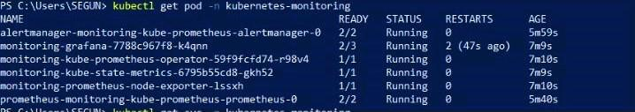

Step 2: Deploying a Helm Charts to Created a Namespace

Run a helm install command indexed under to installation the Helm chart for the kube-prometheus stack after including the Helm repo. You can use another call in place of "monitoring."

In This Helm chart configures a radical Prometheus Kubernetes monitoring stack by using performing on a group of Custom Resource Definitions (CRDs). Run the subsequent commands to installation the chart to the Kubernetes cluster.

helm install Prometheus Prometheus-community/kube-Prometheus-stack --namespace monitoring

To a verify the deployment of your Kube-Prometheus stack, and run the following command.

kubectl get pods -n monitoring

Step 3: For Accessing a Prometheus Instance and Viewing a Internal State Metrics

In a next step is to make use of Prometheus and Grafana to display your Kubernetes cluster after you've got efficiently deployed their instances there. You could be able to use your browser to get entry to the Prometheus server as a end result. To discover which Prometheus server you will be redirecting traffic to, run the command under.

kubectl get svc -n monitoring

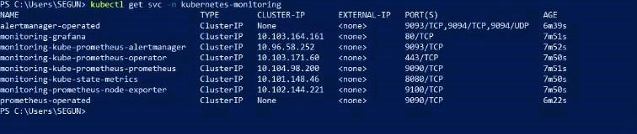

In Next, run the beneath kubectl port forward command to forward the nearby port 9090 for your cluster thru the Prometheus provider (svc/monitoring-kube-Prometheus-Prometheus). To be achieve this run the following commands.

kubectl port-forward svc/Prometheus-kube-Prometheus-Prometheus -n monitoring 9090

for Open a web browser, and navigate to either of the URLs below to access your Prometheus instance.

In a Navigate to http://localhost:9090 if you’re following along local windows, Linux, or mac machines. In Navigate to your server’s IP address followed by port 9090 (i.e., http://YOUR_SERVER_IP:9090) .

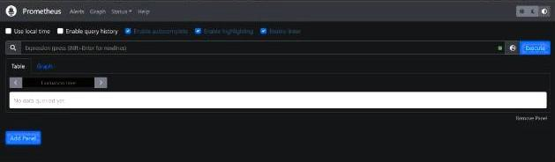

Step 4: For Visualizing a Cluster’s Internal State Metric on a Prometheus

To view the inner fame metrics of our Kubernetes cluster, we are able to now run few Prometheus queries. We'll focus on CPU usage. For a extra statistics on the Prometheus query language, You can be visit Prometheus' reliable internet site.

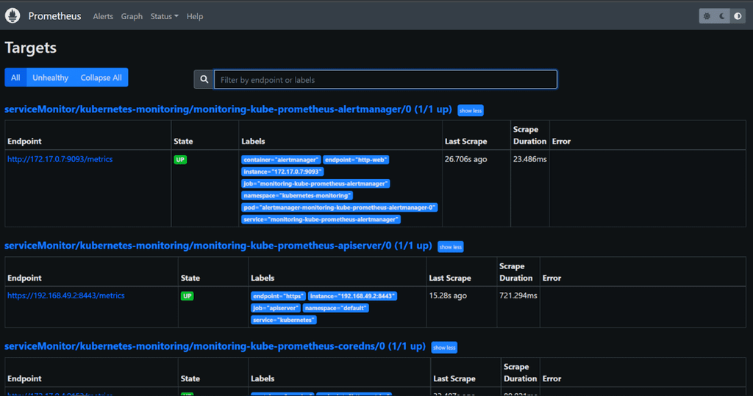

Click the graph icon in top bar, enter following commands in search box to run query, and then click on the graph bar below search bar.

Sum by (cpu)(m=node_cpu_seconds_total{mode!="idle"})

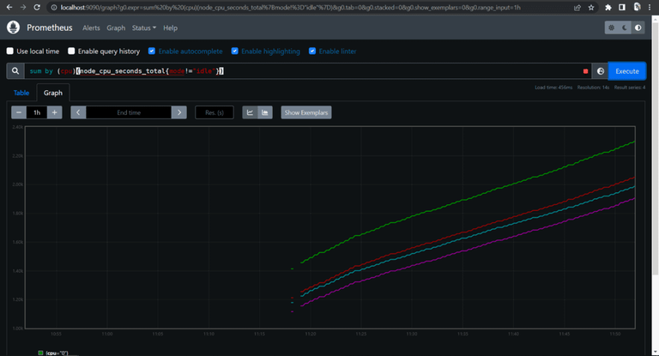

Step 5: Monitoring and a Visualizing with a Grafana Dashboard

For Prometheus visualization alternatives are constrained, best a Graph. Prometheus is tremendous for gathering metrics from targets set as responsibilities, aggregating the metrics, and storing them regionally at the computer. However, while it comes to standard useful resource tracking including Grafana is a exquisite alternative.

kubectl get secret -n kubernetes-monitoring monitoring-grafana -o yaml

$ kubectl get secret -n kubernetes-monitoring monitoring-grafana -o yaml
apiVersion: v1
Data:
admin-password: chjvb51vcGVyYXRvcg
admin-user: YWRtaw4-
kind: secret
metadata
annotations:
meta.heml.sh/release-name: monitoring
meta.heml.sh/release-namespace: kubernetes-monitoring
creationTimestamp: "2022-07-30T11:14:592"
Labels:
app.kubernetes.io/insance: monitoring
app.kubernetes.io/managed-by: Helm
app.kubernetes.io/name: monitoring
app.kubernetes.io/version: monitoring
helm.sh/chart: grafana-6.32.9
name: monitoring-grafana
namespace: kubernetes-monitoring
resourcesVersion: "3966"
vid: 3774e7dd-a294-473e-8482-2bda3769b37a
type: opaque

In a Metrics produced via server components which includes node exporter, Core DNS, and others are accrued through Prometheus. Grafana obtains these metrics from Prometheus and shows them in some of methods on its dashboard.

kubectl port-forward svc/monitoring-grafana -n kubernetes-monitoring 3001:80

In a Next type the admin-username and the password you have be a decoded to login.



Now to the start a monitoring, type of this URL in your browser

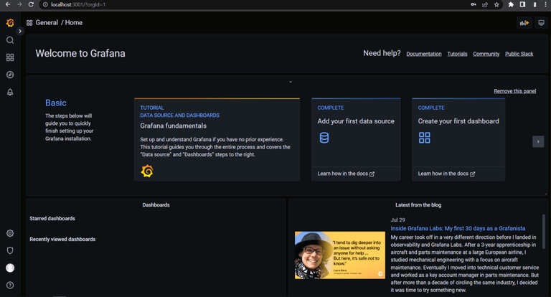

In a http://localhost:3001/dashboards or http://YOUR_SERVER_IP:3001/dashboards> if you’re using the cloud server.

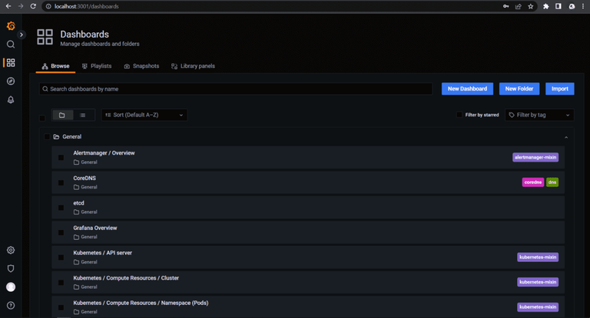

Follow same steps to select dashboards for a Kubernetes resources and you want to be manage and monitor.

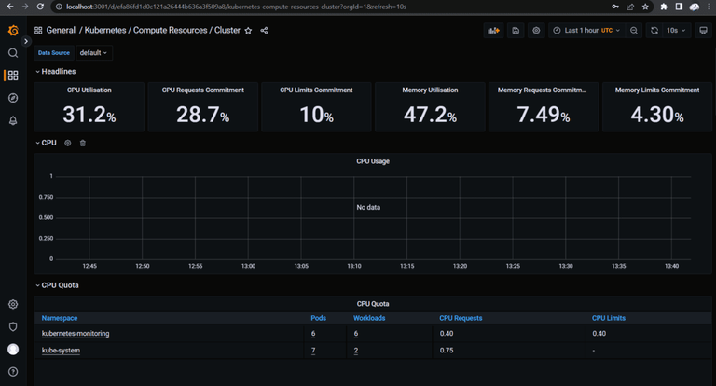

Working with Prometheus and Grafana Using Helm

Helm is a package manager for Kubernetes that allows you to install, upgrade, and manage applications on your Kubernetes cluster. With Helm, you can define, install, and upgrade your application using a single configuration file, called a Chart. Charts are easy to create, version, share, and publish, so you can collaborate with your team and the larger Kubernetes community.

There are many charts available in the Helm stable repository, which is maintained by the Helm community, and you can also find charts from other sources or create your own custom charts. Helm makes it easy to automate the deployment and management of applications on your Kubernetes cluster, so you can focus on building great software.

Prometheus

Prometheus is an open-source monitoring system that is especially well-suited for cloud-native environments, like Kubernetes. It can monitor the performance of your applications and services, and alert you if there are any issues. It has a powerful query language that allows you to analyze the data it collects, and it also has a rich set of integrations with other tools and systems. For example, you can use Prometheus to monitor the health of your Kubernetes cluster, and use its integration with Grafana to visualize the data it collects.

Prometheus is a standalone system, but it can also be used in conjunction with other tools like Alertmanager to send alerts based on the data it collects. You can also use Prometheus to monitor the performance of your applications and services, and use its integrations with tools like PagerDuty to send alerts to the appropriate on-call personnel.

In summary, Prometheus is a powerful monitoring tool that is well-suited for cloud-native environments, and it has a wide range of integrations with other tools and systems to help you monitor and manage your applications and services.

Prometheus Architecture

A main server that scrapes and stores time series data

A query language called PromQL is used to retrieve and analyze the data

A set of exporters that are used to collect metrics from various systems and applications

A set of alerting rules that can trigger notifications based on the data

An alert manager that handles the routing and suppression of alerts

The Prometheus server stores the data in a time series database, and it also provides a web interface that you can use to query and analyze the data using PromQL. The web interface also includes a dashboard builder that allows you to create custom dashboards to visualize your data.

Prometheus also includes a built-in alert manager that can send notifications based on the data it collects. You can define alerting rules that specify when an alert should be triggered, and the alert manager will route and suppress the alerts as needed.

In summary, Prometheus is a powerful monitoring system that is designed to collect, store, and analyze time series data, and to alert you if there are any issues. It has a modular architecture that allows you to customize and extend it to meet your specific needs.

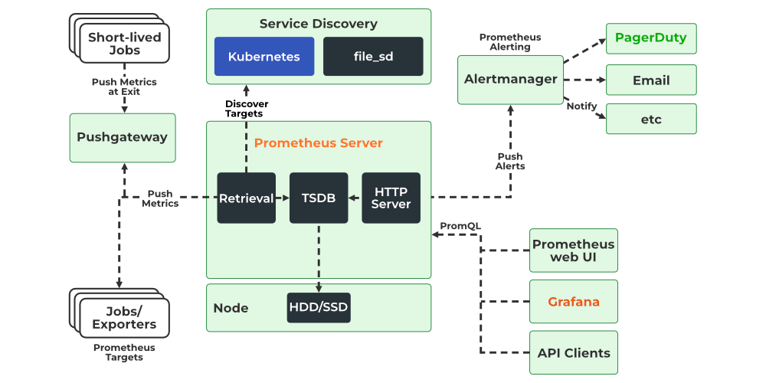

Step 1: Add Repositories. Add the following helm repositories by the commands below.

$ helm repo add prometheus-community https://prometheus-community.github.io/helm-charts/

$ helm repo add stable https://charts.helm.sh/stable/

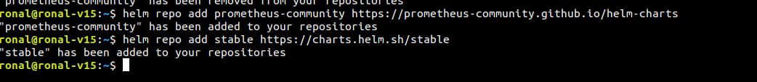

Step 2: Update Helm Repositories. After we add the helm repositories, we have to update the helm repo by the following command.

$ helm repo update

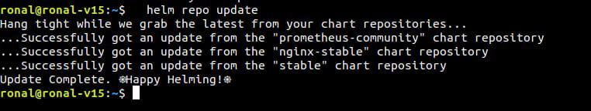

Step 3: Install Prometheus Kubernetes

$ helm install prometheus prometheus-community/kube-prometheus-stack

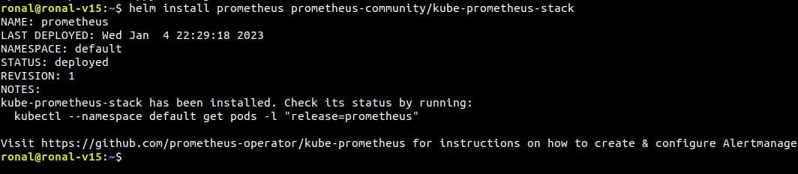

Step 4: Kubernetes Prometheus Port Forward

$ kubectl port-forward deployment/prometheus-grafana 3000

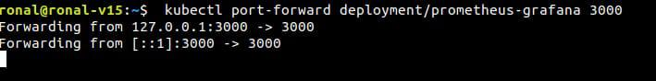

Step 5: Log in to Grafana.

Open your browser and type localhost:3000. Since you are logging in for the first time, you will have to use a default username and password. However, you can create new users and update passwords later. Use the default credentials for now

username: admin
password: prom-operator

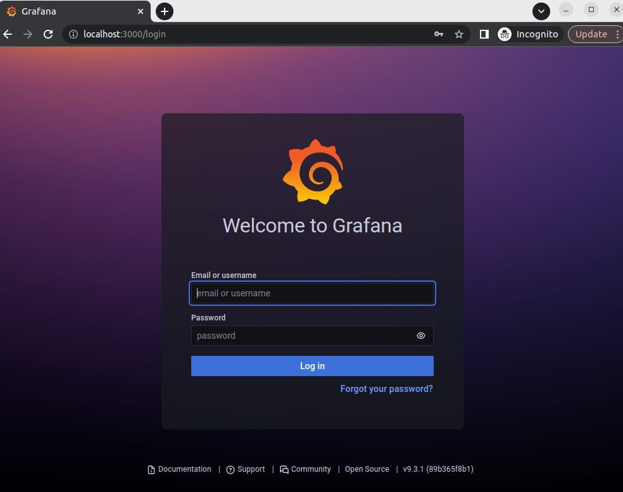

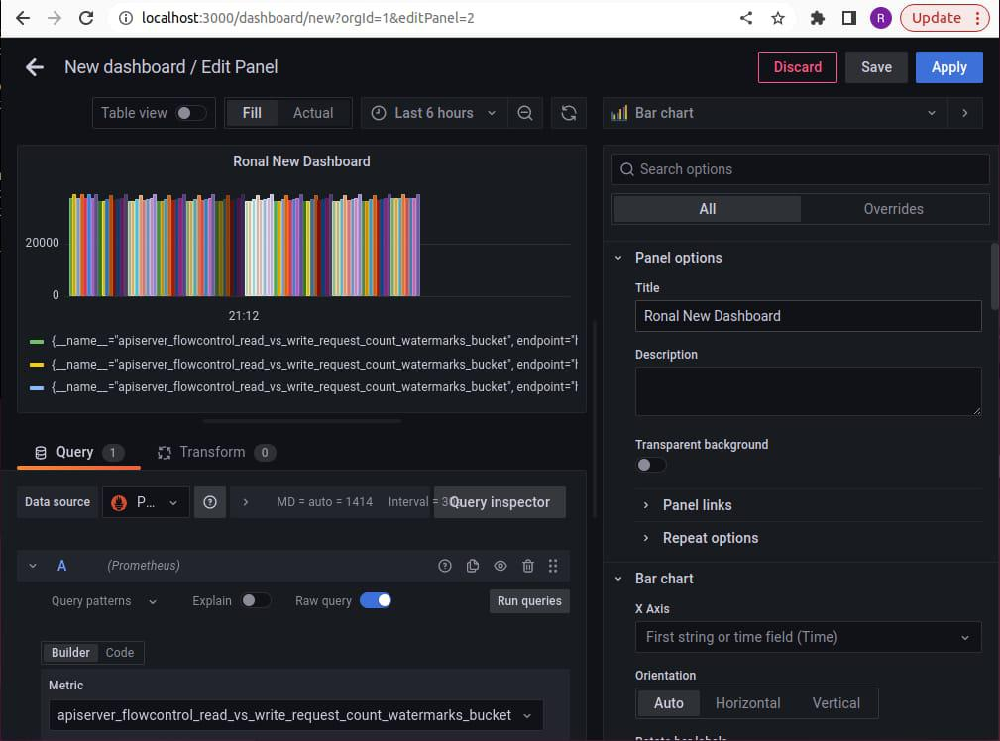

Setting up Grafana on EC2 to query metrics from Amazon Managed Service for Prometheus

The recently launched Amazon Managed Service for Prometheus (AMP) service provides a highly available and secure environment to ingest, query, and store Prometheus metrics. We can query the metrics from the AMP environment using Amazon Managed Grafana, a self-hosted Grafana server, or using the HTTP APIs.

In this article, we will look at how to configure a self-hosted open source Grafana server on Amazon Elastic Compute Cloud (Amazon EC2) to connect an AMP data source and create a dashboard.

Install Grafana Enterprise server on Amazon EC2.

Enable SigV4 authentication through built-in AWS SDK in Grafana (v7.3.5 onward).

Set up an Application Load Balancer (ALB) to access Grafana server externally.

Add AMP as data source in Grafana using SigV4 authentication.

Query the metrics from AMP to verify the setup works as expected.

Install Grafana Enterprise server on EC2
Next, create an Amazon Linux 2 Amazon Machine Image (AMI) based EC2 instance and assign an IAM role that has the managed policy arn:aws:iam::aws:policy/AmazonPrometheusQueryAccess attached to it. If you want to use a custom policy, ensure the policy has the following permissions:

{ "Version": "2012-10-17",
"Statement": [
{
"Action": [
"aps:GetLabels",
"aps:GetMetricMetadata",
"aps:GetSeries",
"aps:QueryMetrics"
],
"Effect": "Allow",
"Resource": "*"
}
]}

Option 1: Install using binary .tar.gz file. Download and extract the Grafana server binaries by executing the following commands. We are following instructions in the Grafana documentation.

wget https://dl.grafana.com/enterprise/release/grafana-enterprise-7.3.6.linux-amd64.tar.gztar -zxvf grafana-enterprise-7.3.6.linux-amd64.tar.gz

You should be able to see a directory with the name of the Grafana version installed. Because we install Grafana version 7.3.6, we are able to see a directory with name grafana-7.3.6 on the EC2 instance.

Option 2: Install using YUM repository. Optionally, you can also install the Grafana server as a systemd process by following instructions from the Grafana documentation.

After the installation, you should see a screen similar to the following:

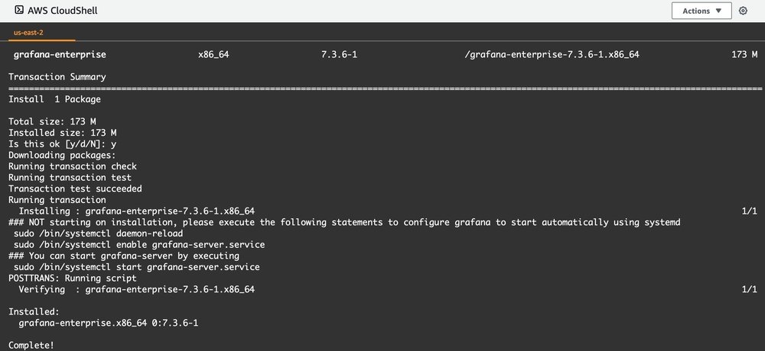

Enable SigV4 authentication through built-in AWS SDK in Grafana (v7.3.5 onward)
If you used Option 1 in the previous step, execute the following commands to set the required environment variables:

export AWS_SDK_LOAD_CONFIG=true export GF_AUTH_SIGV4_AUTH_ENABLED=true

Next, execute the following command to start the Grafana server:

./bin/grafana-server web

If you used Option 2 to install Grafana, you can start the server using systemd. Before that, set the required environment variables to enable SigV4 auth by executing the following command:

sudo systemctl edit grafana-server

This step will open the vi editor, where we need to paste the following configuration. Save the file and exit the editor.

[Service]Environment="GF_AUTH_SIGV4_AUTH_ENABLED=true"Environment="AWS_SDK_LOAD_CONFIG=true"

Execute the following command to start the Grafana server:

sudo systemctl start grafana-server

We can check that the server is running as expected by executing the following command:

sudo systemctl status grafana-server

You should see a screen similar to the following, indicating that the server has started successfully:

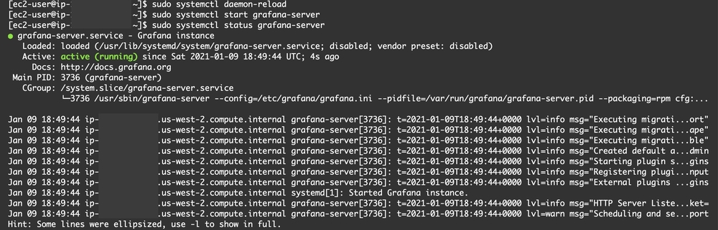

Your Grafana server is now up and running. You can check this by executing the following command. You should see a response:

curl http://localhost:3000 -L

Set up an ALB to access Grafana server externally

As a best practice, we’ll create an ALB that uses a Target Group to forward HTTP requests to the EC2 instance on port 3000 (which is the default Grafana port).

Add AMP as data source in Grafana using SigV4 authentication
Log in to Grafana using the ALB URL. Provide the default credentials admin/admin to log in.

Once logged in, we go to the Data Sources screen from Settings:

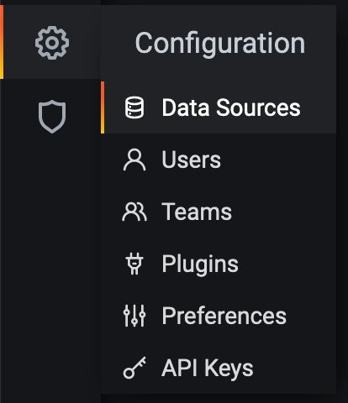

Select Add data source, then Prometheus from the list as shown below:

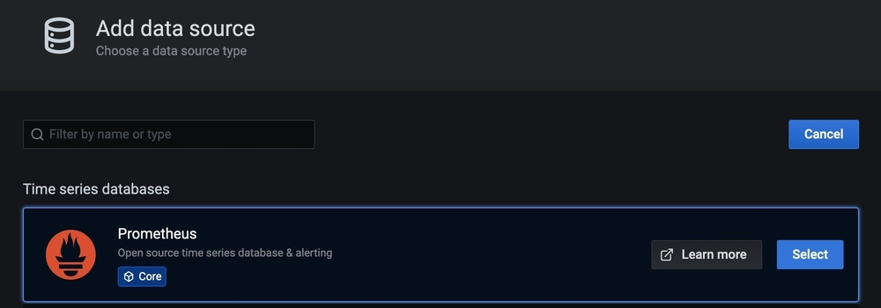

Next, we paste the AMP Endpoint query URL (find this under the Summary tab on the AMP workspace) leaving out the api/v1/query portion (for example, https://aps-workspaces.us-west-2.amazonaws.com/workspaces/ws-3aa5f57b-yy11-xx00-12ab-ea86005d6dd7/) in the URL field under HTTP. We need to enable SigV4 auth in the Auth section.

We also need to ensure that AWS SDK Default is selected in Authentication Provider under the Sigv4 Auth Details section, then select the AWS Region in which the AMP workspace was created earlier in the Default Region drop-down. See the following screenshot for details.

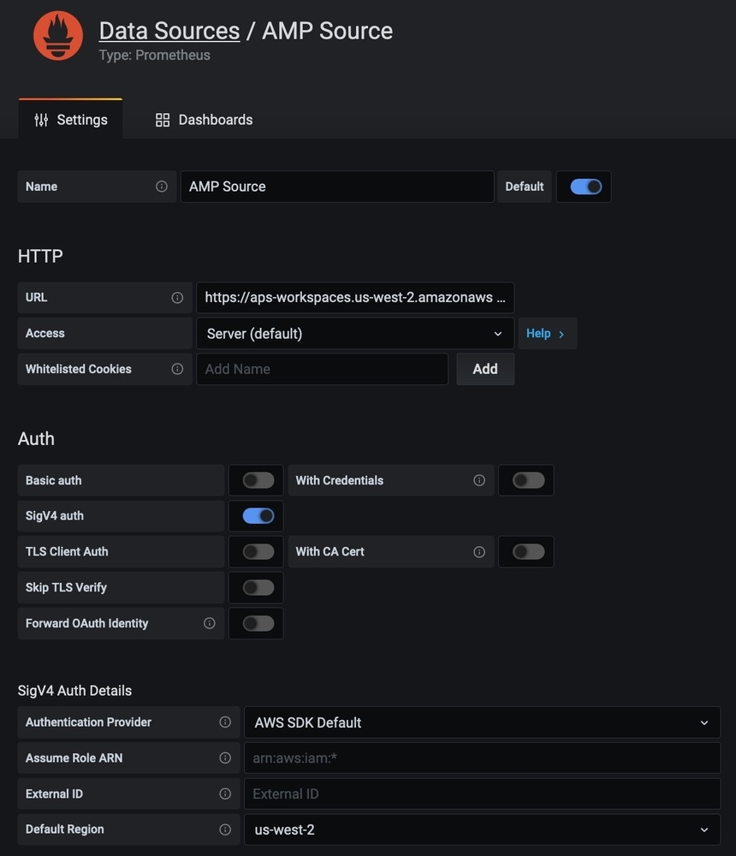

Next, we can choose Save & Test. We should see a green banner that says “Data source is working” as shown in the following.

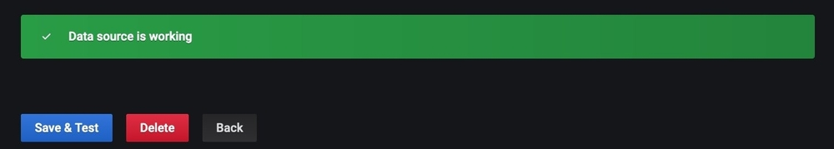

Query the metrics from AMP to verify the setup
Next, we’ll create a new Dashboard from the left navigation bar by choosing the + sign.

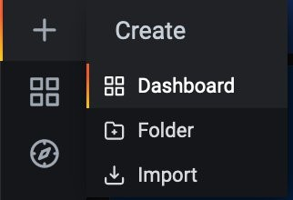

We then add a new panel and select the new AMP data source configured previously.

We can write a simple PromQL query in the Metrics textbox, and we should see the metrics in the panel as shown in the screenshot:

